BUILD A WEB APPLICATION USING NODE-RED SERVICE

|  |  |
| --- | --- |
| Team ID | PNT2022TMID02439 |
| Project Name | SmartFarmer - IoT Enabled Smart Farming  Application |
| Team Members Name | Kamesh Kumar K , Kaviyaraj C , Javeed Akram Z , KavinSaran JK |

# Step:1 Go to Your Node-Red Flow Editor

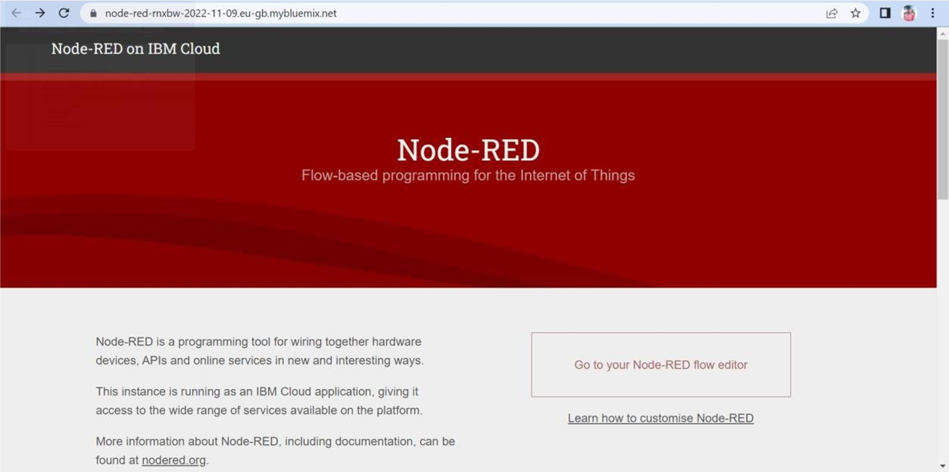

# Step:2 Design the Required flows to Create Web Application

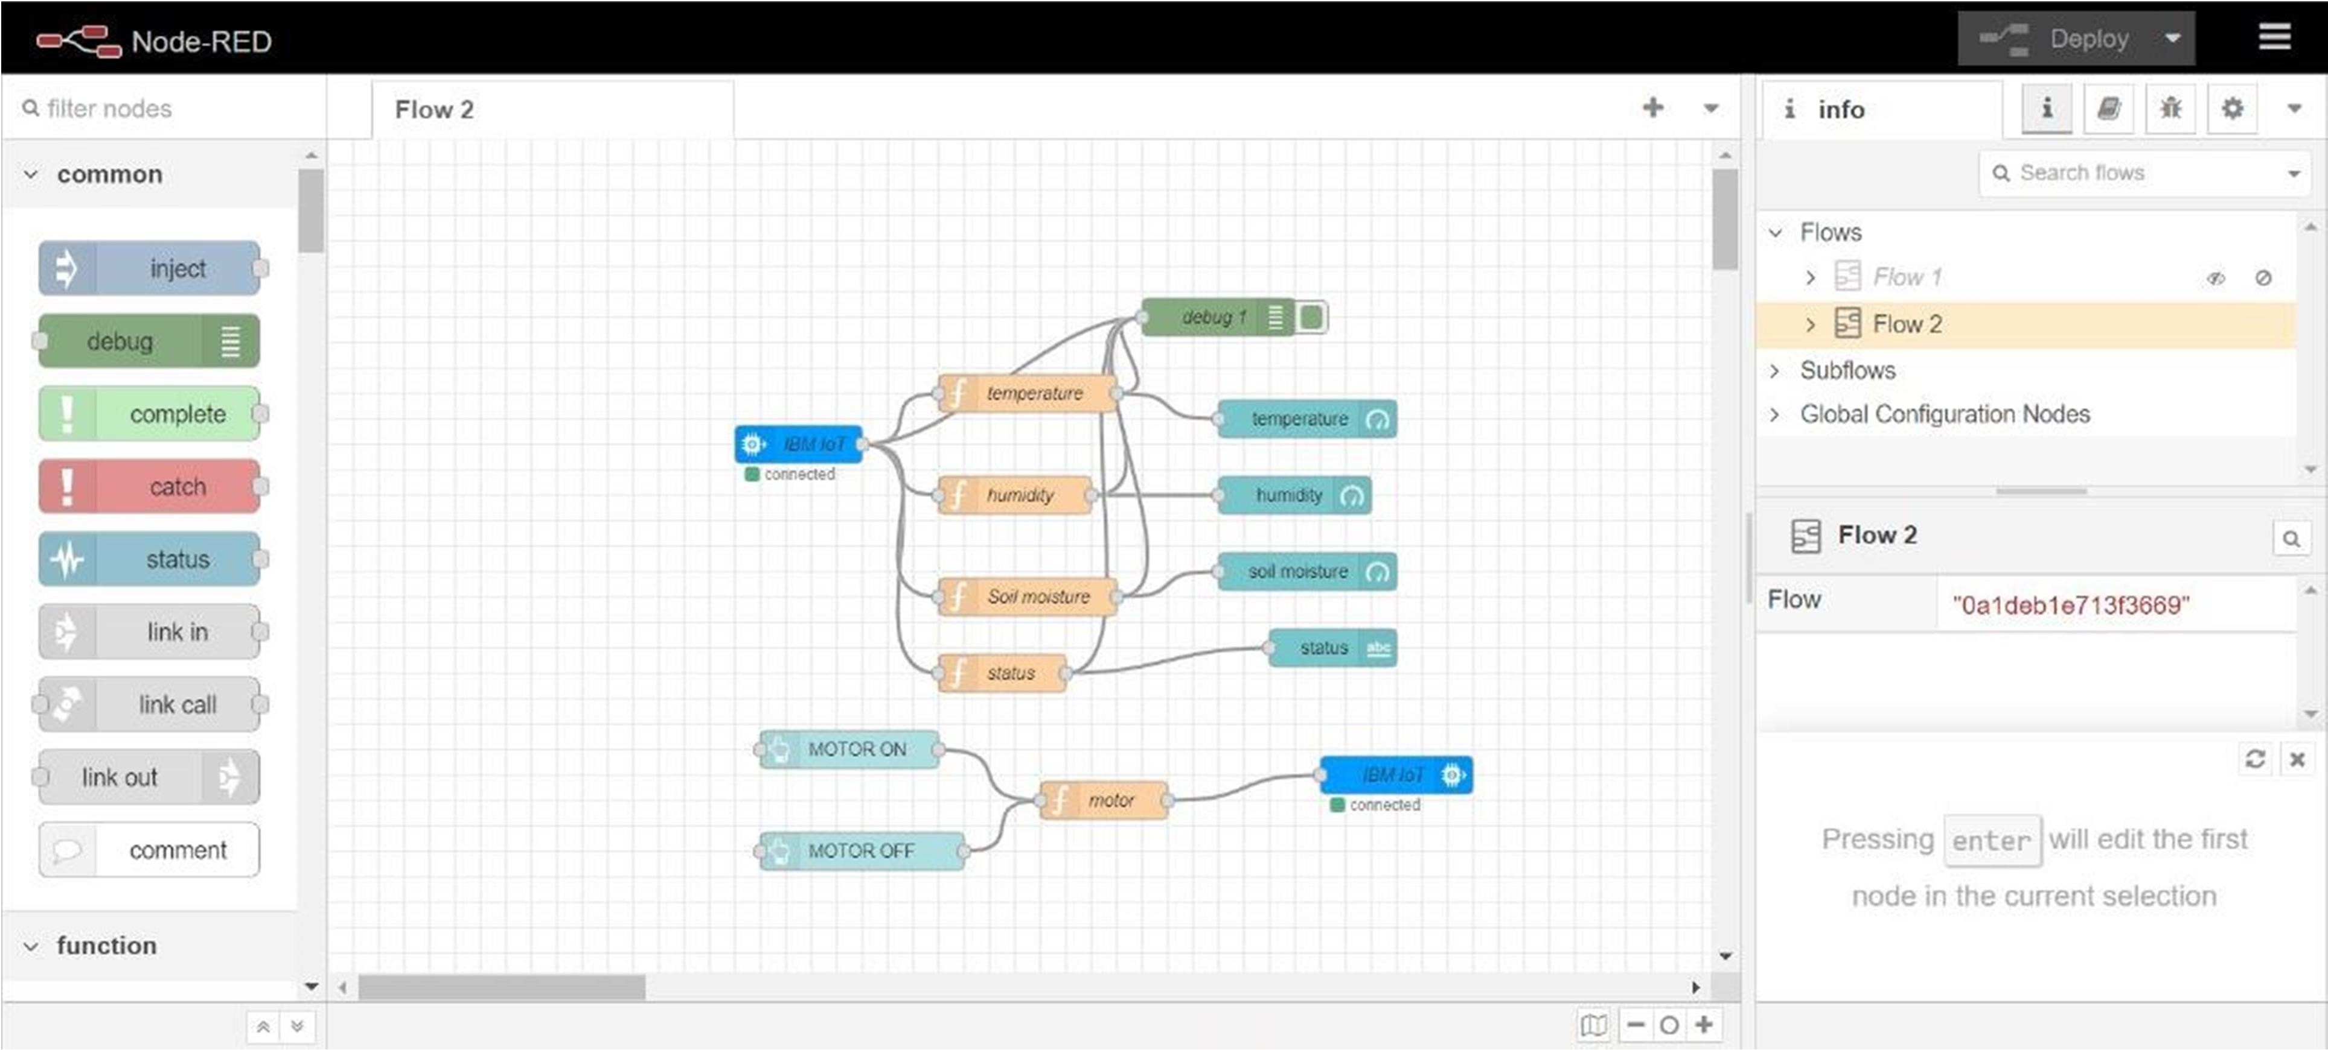

# Step:3 Getting the command From The user to Control the Motor

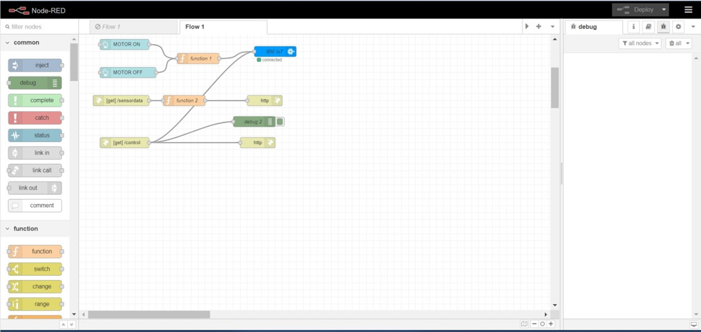

# Step:4 Temperature message Flow

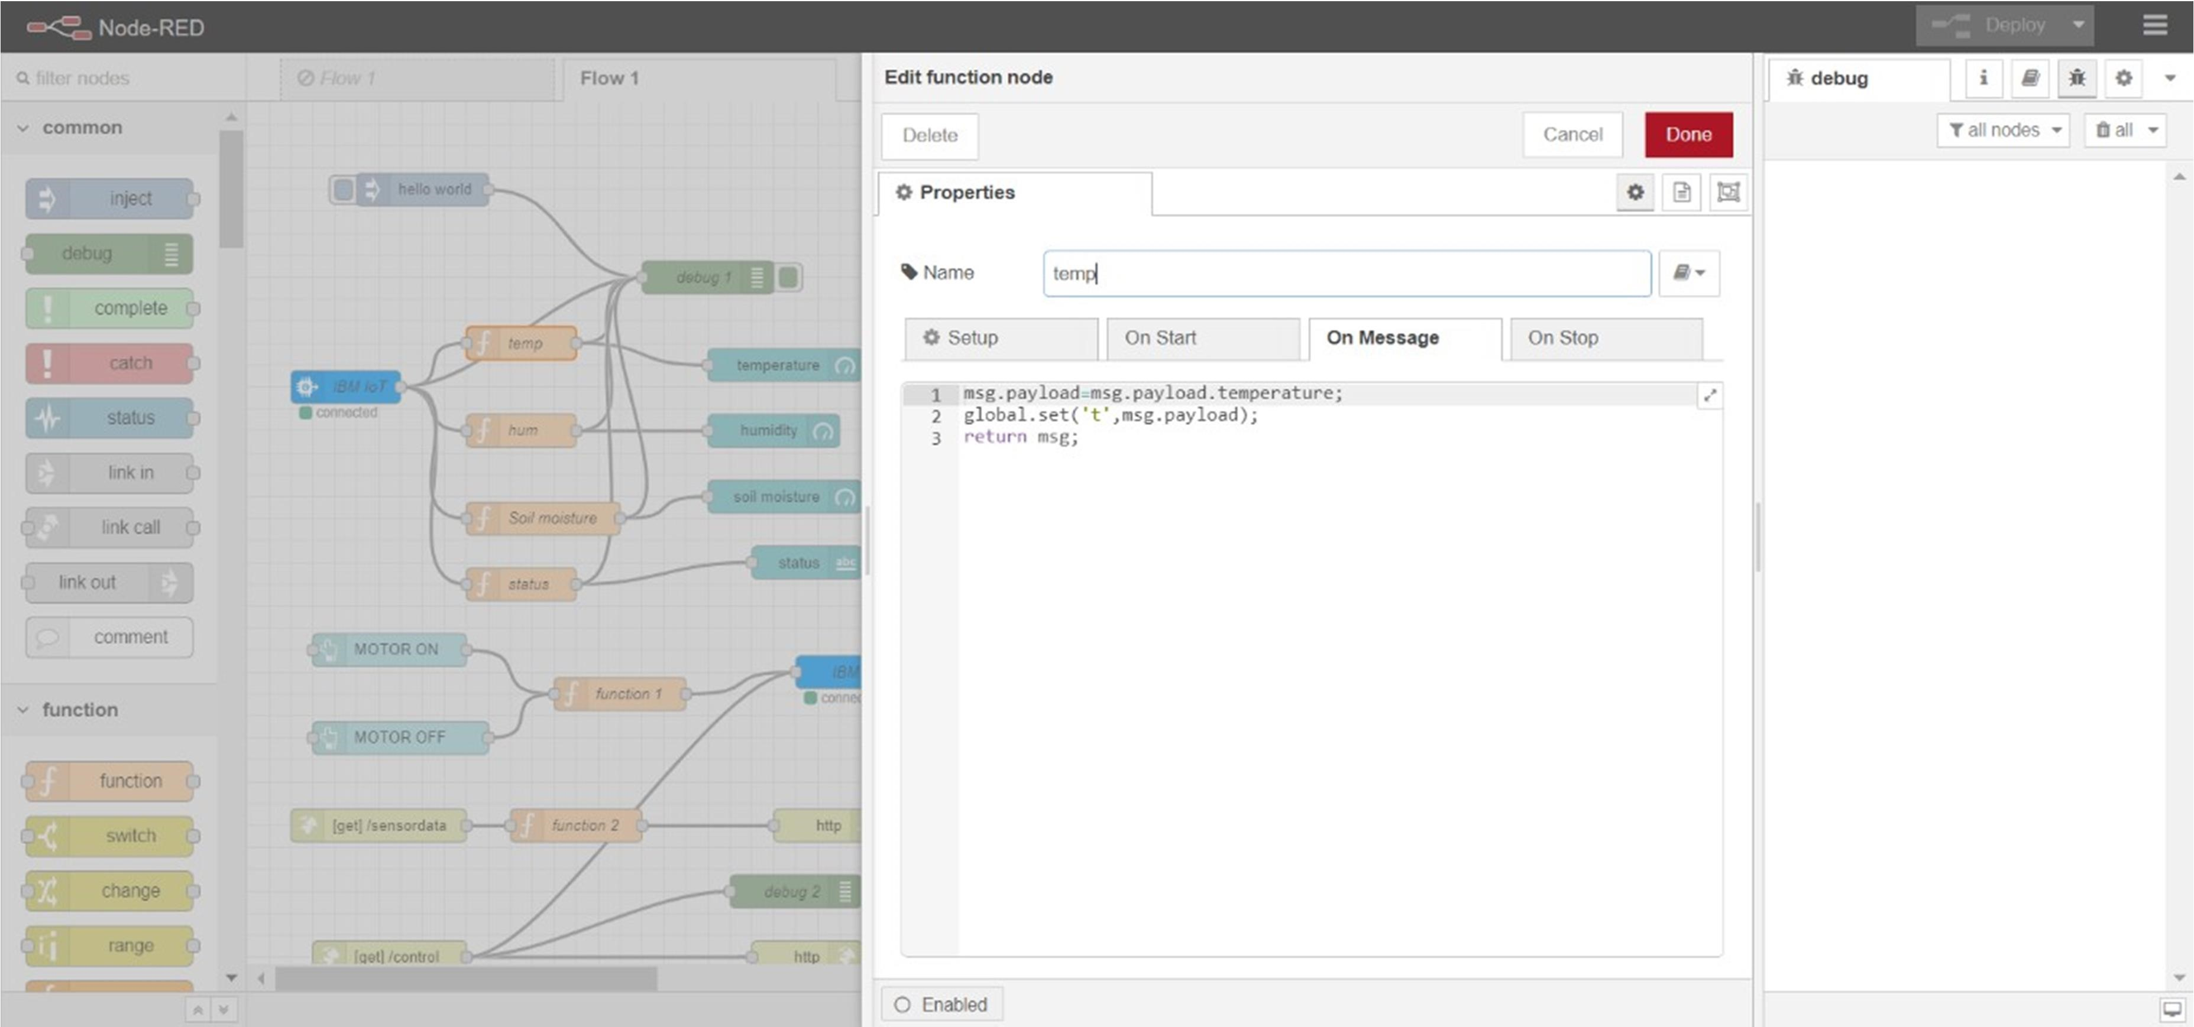

# Step:5 Humidity Message Flow

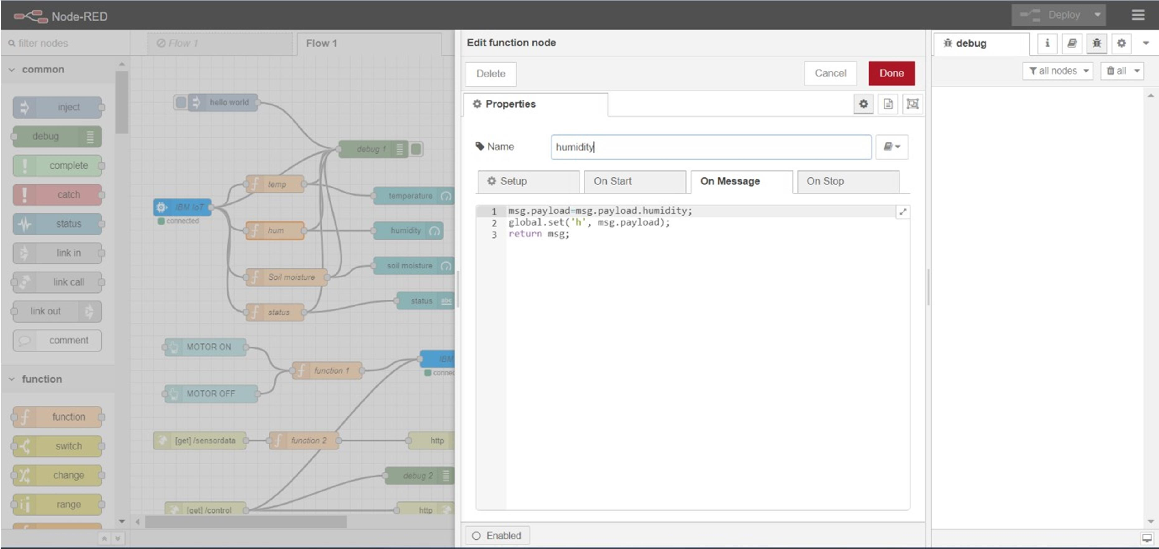

Step:6 Soil Moisture Flow

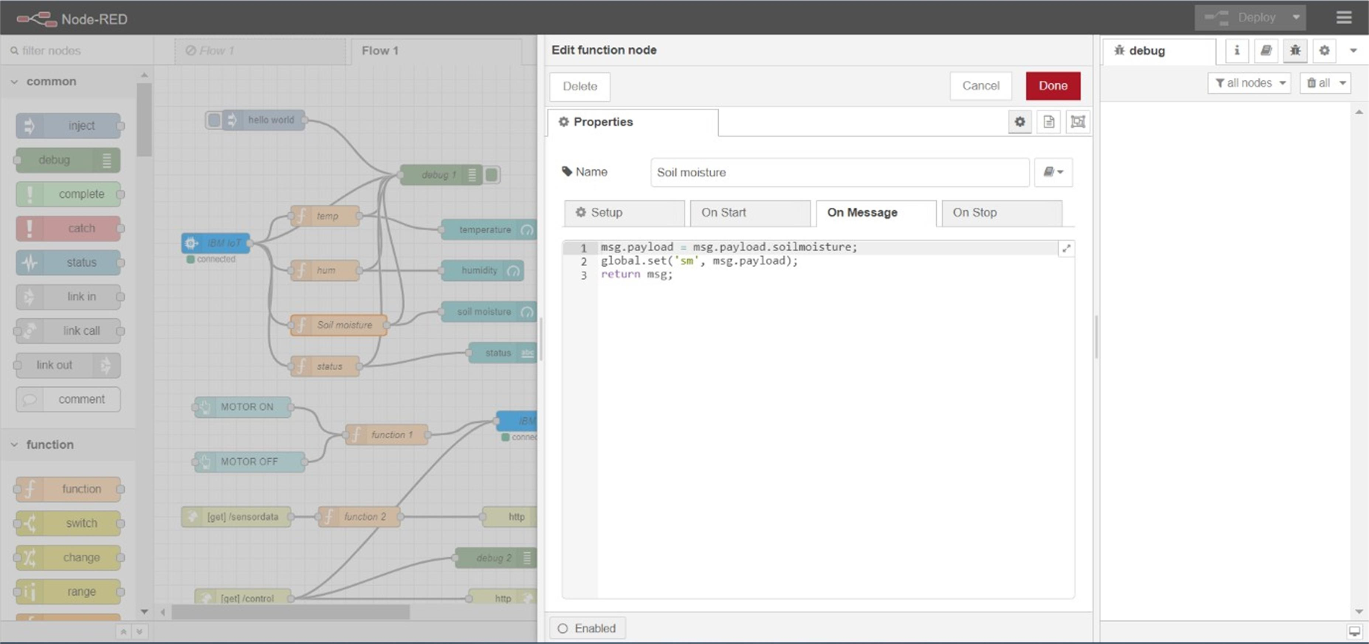

# Step:7 Final Web UI Output

